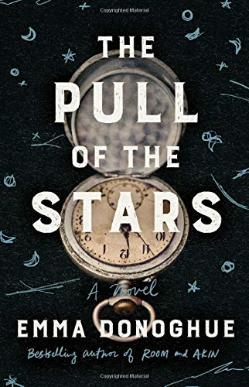  (2020) | ICC/McClelland Library Book Discussion Group  January 29, 2022  10:30 AM – 12:30 PM  Find the Guide and other information on our webpage (via azirish.org). Be certain that your email address is registered here so that you get the latest emails. The Guide will be available in early January; we’ll send a reminder near the date of the discussion.

Emma Donoghue wrote The Pull of the Stars in 2018 to commemorate the centenary of the 1918 flu epidemic in Dublin. Her final draft to her publisher was submitted just as the current pandemic hit in March 2020.
What does this historical novel tell us about 1918 Dublin?
- Role of class, gender, and religion
- Poverty
- Attitudes toward the Irish Independence movement
- Irish soldiers who served in the English army in World War I
What similarities do you see between the 1918 flu epidemic and our current COVID pandemic?
Are there other similarities that resonate with our time?
The three main characters are Julia Powers, Bridie Sweeney, and Dr. Kathleen Lynn. How did they change each other’s lives? How were their roles impacted by society’s view of the role of women? How did this view affect the lives of their patients?
What significance do you find in the author’s use of colors in the four section headings?
What do you think Donoghue did well? What might have she improved? Why do you think she selected the location and these particular characters?
The Zoom link for this discussion will be sent the week before the discussion.
Looking ahead:
Eclipsed (1992 play) by Patricia Burke Brogan discussion on February 26, 2022.

